

DAYANANDA SAGAR COLLEGE OF ENGINEERING
An Autonomous Institute Affiliated to VTU, Belagavi Approved by AICTE; ISO 9001:2015
Certified Accredited by National Assessment Accreditation Council (NAAC) with ‘A’ grade
Shavige Malleshwara Hills, Kumaraswamy Layout, Bengaluru-560078

DEPARTMENT OF COMPUTER SCIENCE & ENGINEERING

Academic Year | 2025-2026 | L: T: P: S: | 0:2:0:0
Course Title | Mobile Application Development Lab | Course code | 22CSL54
Credit Units | 1 | Course Type | PCCL
Exam Hours | 3 hours | CIE Marks | 50
Total Hours: | 2 hours | SEE Marks | 50

Course objectives:
- Learn and acquire the art of Android Programming.
- Configure Android studio to run the applications.
- Understand and implement Android's User interface functions.
- Create, modify, and query on SQLite database.
- Inspect different ways to accomplish background processing in Android

Course Outcomes: At the end of the course, students will be able to:
CO1 | Develop, test and debug android applications in Android Studio.
CO2 | Design adaptive, responsive user interfaces with backend data processing that work across a wide range of mobile devices.
CO3 | Develop form based applications for simple tasks using data storage and retrieval libraries.

Expt No | Content of the Experiment | Hours | CO’s
 | PART - A
1. | Introduction to Mobile Application Development, Android Studio installation and project creation.  Create an application to design a Dream Job Visiting Card. The Visiting card should have a company logo at the top right corner. The company name should be displayed in Capital letters, aligned to the center. Information like the name of the employee, job title, phone number, address, email, fax and the website address is to be displayed. Insert a horizontal line between the job title and the phone number  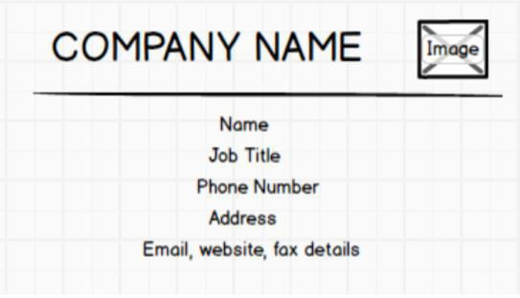  . | 2 | CO1
2. | 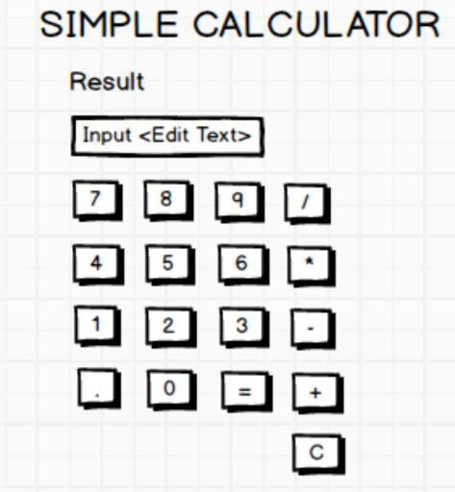  Develop an Android application using controls like Button, TextView, EditText for designing a Calculator having basic functionality like Addition, Subtraction, Multiplication, and Division. | 2 | CO1
3. | 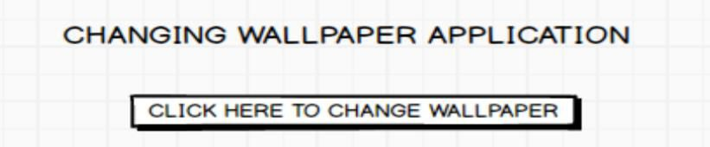  Develop an application to set an image as wallpaper. On click of a button, the wallpaper image should start to change randomly every 30 seconds. | 1 | CO1
4. | Write a program to create an activity with two buttons START and STOP. On Pressing of the START button, the activity must start the counter by displaying the numbers from One and the counter must keep on counting until the STOP button is pressed. Display the counter value in a TextView control.  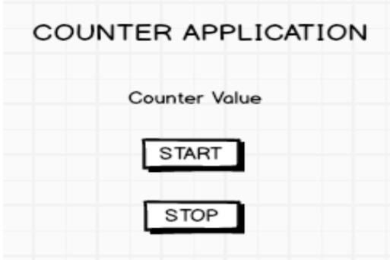 | 1 | CO2
5. | Create a SIGN-UP activity with Username and Password.  - Password should contain uppercase and lowercase letters.  - Password should contain letters and numbers.  - Password should contain special characters.  - Minimum length of the password (the default value is 8).  Password should be validated based on rules. On successful SIGN UP proceed to the next Login activity. Here the user should SIGN IN using the Username and Password created during signup activity. If the Username and Password are matched, then navigate to the next activity which displays a message saying “Successful Login” or else display a toast message saying “Login Failed”. The user is given only two attempts and after that display a toast message saying “Failed Login Attempts” and disable the SIGN IN button. Use Bundle to transfer information from one activity to another.  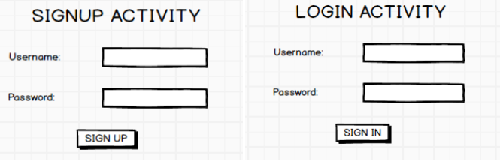 | 2 | CO2
6. | Write a program to enter Medicine Name, Date and Time of the Day as input from the user and store it in the SQLite database. Input for Time of the Day should be either Morning or Afternoon or Evening or Night. Trigger an alarm based on the Date and Time of the Day and display the Medicine Name.  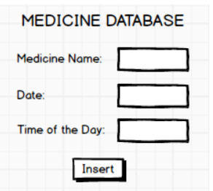 | 2 | CO2
 | PART - B
7. | Mini Project- Develop an Android Application of your choice which implements all the concepts covered. Demonstration with Report should be submitted. | 2 | CO3

Reference Books:
- Erik Hellman, “Android Programming – Pushing the Limits”, 1st Edition, Wiley India Pvt Ltd, 2014. ISBN-13: 978-8126547197.

- Dawn Griffiths and David Griffiths, “Head First Android Development”, 1st Edition, O‟Reilly SPD Publishers, 2015. ISBN-13: 978-9352131341.

- Bill Phillips, Chris Stewart and Kristin Marsicano, “Android Programming: The Big Nerd Ranch Guide”, 3rd Edition, Big Nerd Ranch Guides, 2017. ISBN-13: 978-0134706054

CO-PO, PSO Mapping
 | PO1 | PO2 | PO3 | PO4 | PO5 | PO6 | PO7 | PO8 | PO9 | PO10 | PO11 | PO12 | PSO1 | PSO2 | PSO3
CO1 | 3 | 3 | 3 | - | 2 | - | - | 1 | 2 | 1 | - | 3 | 3 | - | -
CO2 | 3 | - | 3 | - | 2 | - | - | 1 | 2 | 1 | - | 1 | 3 | - | -
CO3 | 3 | 3 | 3 | - | 2 | - | - | 1 | 2 | 1 | - | 3 | 3 | - | -

____________________________ __________________
Faculty In-charge Head, CSE

